Relational Databases with MySQL Week 4 Coding Assignment

**Points possible:** 70

|  |  |  |
| --- | --- | --- |
| Category | Criteria | % of Grade |
| Functionality | Does the code work? | 25 |
| Organization | Is the code clean and organized? Proper use of white space, syntax, and consistency are utilized. Names and comments are concise and clear. | 25 |
| Creativity | Student solved the problems presented in the assignment using creativity and out of the box thinking. | 25 |
| Completeness | All requirements of the assignment are complete. | 25 |

**Instructions:** Using a text editor of your choice, write the queries that accomplishes the objectives listed below. Take screenshots of the queries and results and paste them in this document where instructed below. Create a new repository on GitHub for this week’s assignments and push this document, with your Java project code, to the repository. Lastly, in the Learning Management System, click the “Add Submission” button and paste the URL to your GitHub repository.

**Coding Steps:**

Write 5 stored procedures for the employees database.

Write a description of what each stored procedure does and how to use it.

Procedures should use constructs you learned about from your research assignment and be more than just queries.

1. **getAverageSalaryPerPosition**

Stored procedure retrieves average salary for each position title.

1. **getEmployeeCountByPosition**

Stored procedure retrieves the number of employees per position title. Enter a job title and database would output the number of employees per position.

1. **getDepartmentSize**Stored procedure determines the number of employees for each department and outputs if the department is small, medium, or large by the number of employees.
2. **getCurrentEmployeeTitles**

Stored procedure retrieves the most recent position title from each employee.

1. **getEmployeesGreaterThanSalary**

Stored procedure retrieves employees whose salary is more than any amount and returns back all employees whose salary is higher than the amount specified.

**Screenshots:**

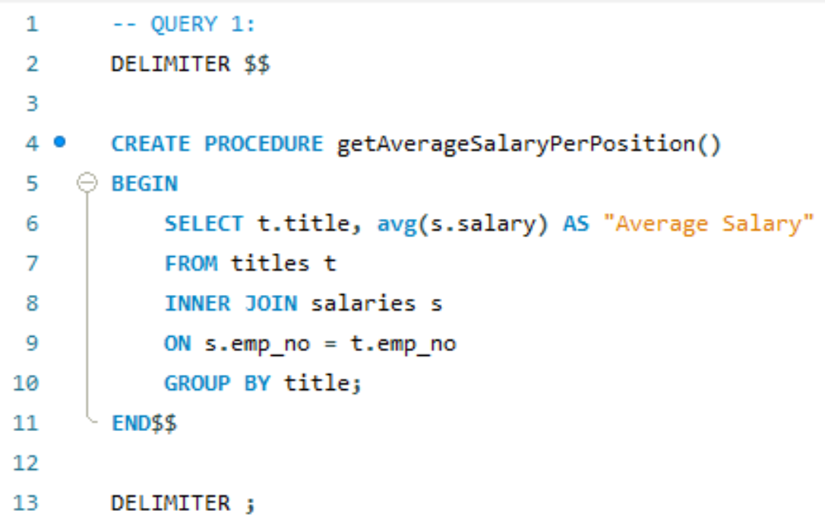

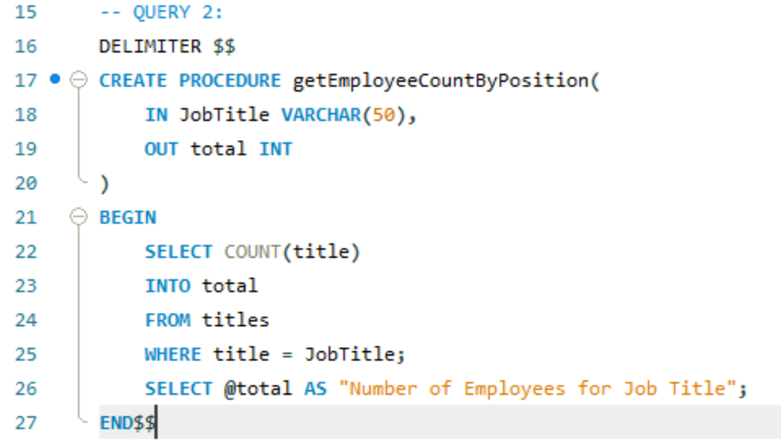

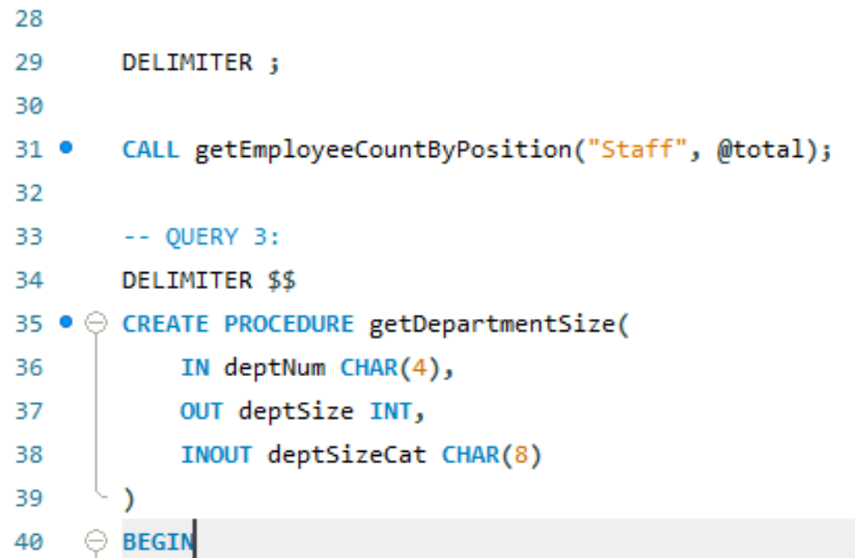

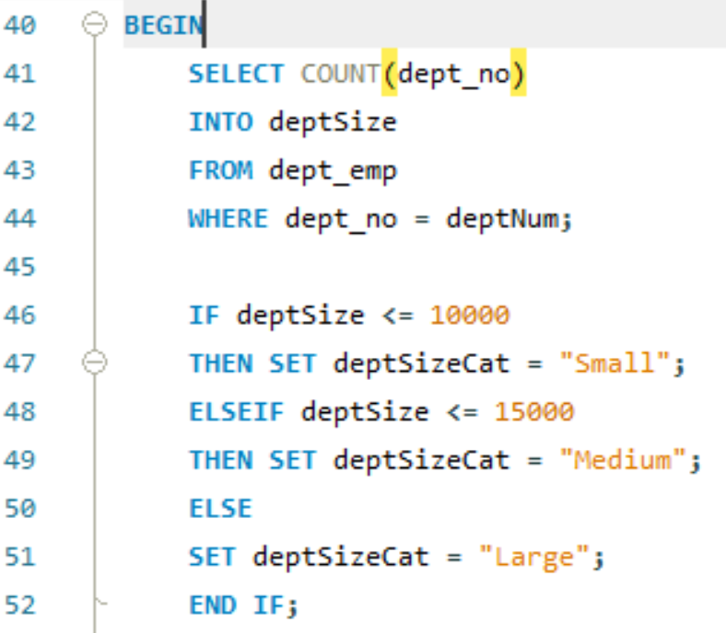

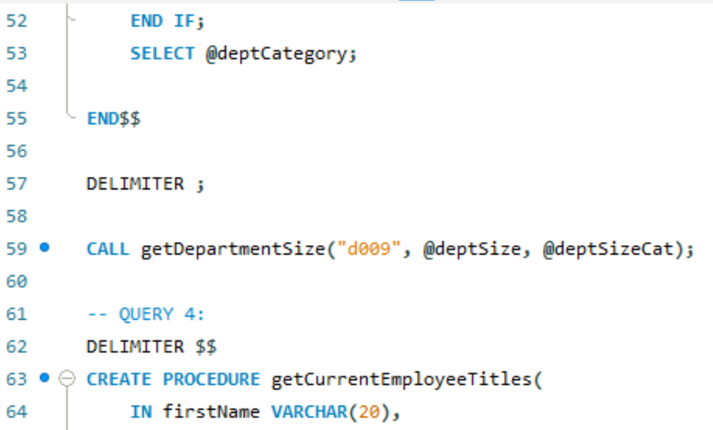

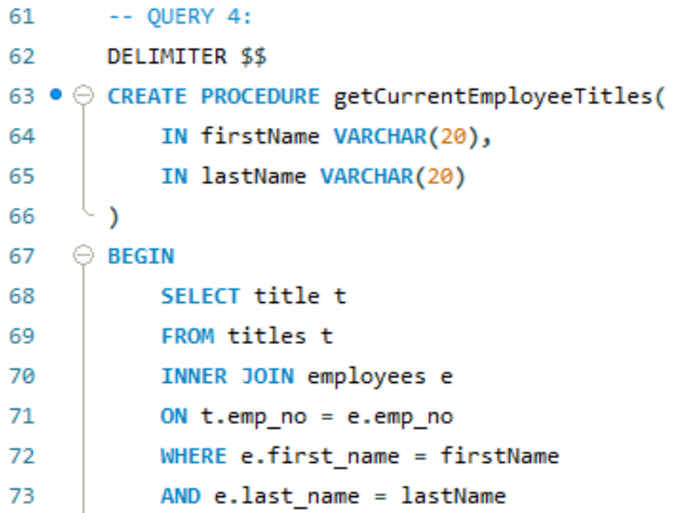

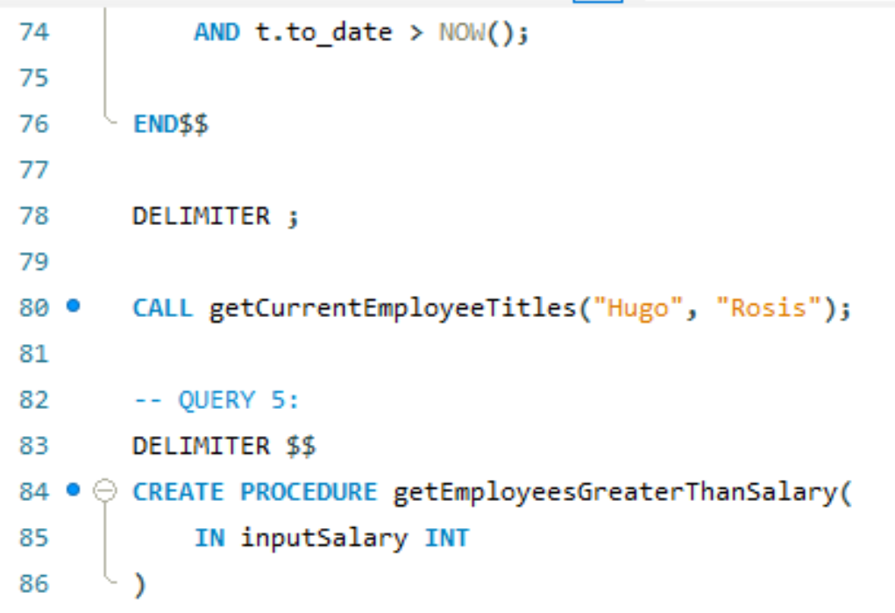

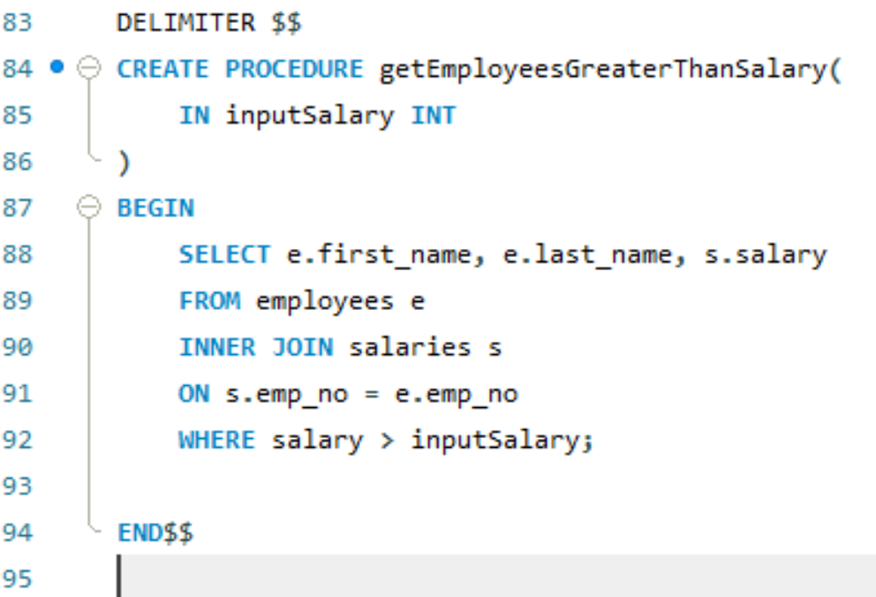

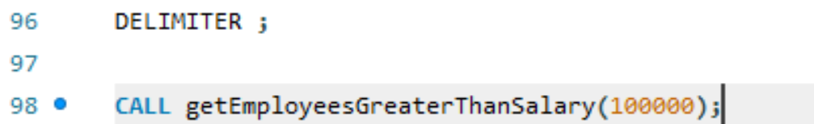

**URL to GitHub Repository: https://github.com/MattShortle96/SQL-Week4**